**CIS 2561 – In-Class Activity A1**

Please complete the following in a small group of your choosing:

1. Create the GUI for a calculator application as shown as problem 2.9 on Page 62 of the textbook. Work so everyone has a chance to add GUI elements to the same form. Follow all instructions from the book to make your version looks as close to identical to the diagram as possible.

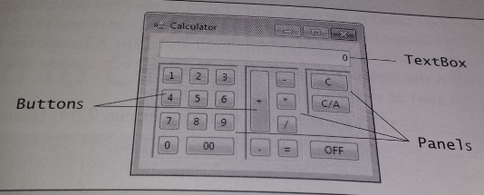

1. Discuss the design elements that would be needed to create a “tip calculator” application. Which GUI elements would need to go into this application? Once you are agreed on an idea, implement it into a form as you just did in the previous problem. You do not need to write any actual code on the back end to implement the program.